15.32: a) 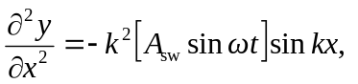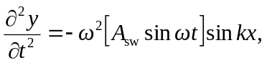
so for 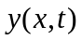 to be a solution of Eq. (15.12), 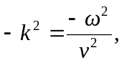 and 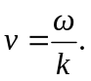
b) A standing wave is built up by the superposition of traveling waves, to which the relationship 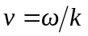applies.

